|  |  |  | **CL117** | | |  |  | **LAB 02** |  |
| --- | --- | --- | --- | --- | --- | --- | --- | --- | --- |
|  | I |  |  |  |  |  |  |  |
|  | **INTRODUCTION** | | | | |  |
|  |  |  | **MS-EXCEL** |  |
|  |  |  |  |  |  |  |  |  |
|  | **TO ICT** | | | | |  |
|  |  |  |  |  |
|  | | | | | | |  | |  |
| **NATIONAL UNIVERSITY OF COMPUTER AND EMERGING SCIENCES** | | | | | | | | |  |

**How to Enter Data in Excel**

1. Open an excel worksheet

2. In the first row, label column A as “Before”, column B as “After”, and column C as “Difference”

3. Enter raw data into the Before and After columns (see image below)

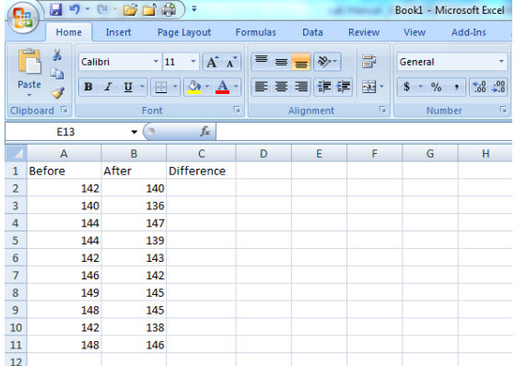

4. In the “Difference” column, enter a function (aka an equation or formula) to tell Excel to subtract the before values from the after values.

* a. Always start a formula with a “=” symbol, then select the cell from column B, then type a “-“ symbol, then select the cell from column A, then hit enter.
* b. The result will be displayed when you hit the enter key (see “-2” and “-4” shown in cells C2 and C3 below). The formula is shown in cell C4.
* c. Once you type in the formula, you can copy and paste that formula into the remaining cells of column C.
* d. If you want to calculate a paired t-test by hand, you will need these difference values. Otherwise, you will not use them to make your graphs or analyses.

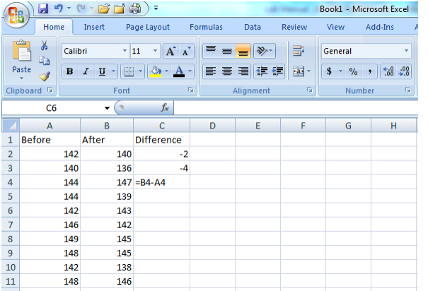

**How to Calculate Summary Statistics in Excel:** **Two Methods**

1. **Use the data analysis tools.**

**A.** Open the worksheet with your data. Select the “Data” tab (1) , then “Data Analysis”(2) , then from the list choose “Descriptive Statistics” (3) and select “OK” .(4)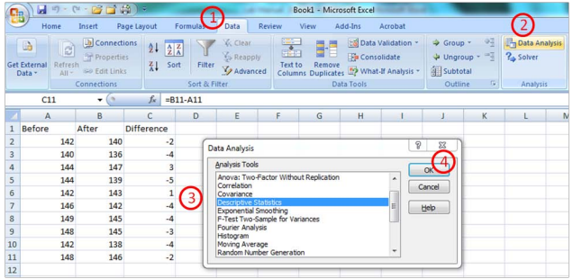

**B.** From here, with your cursor in the Input Range(1) , select your data in column A. Then put your cursor in the Output Range block (2)and select an empty cell in your work sheet. Click the box labeled “Summary Statistics”(3) so a check mark appears, then select “OK” (4).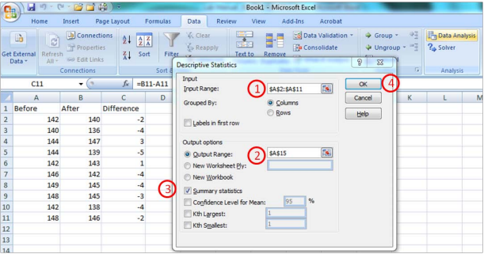

**C.** Excel will now show you the summary statistics. I have added highlights to show the mean, standard deviation, standard error, and sample size which are the summary statistics that you will most commonly use for your write-ups in our labs.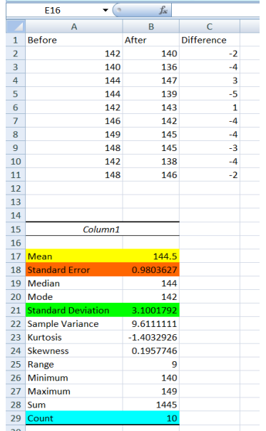

1. **Type in the formulas. For any formula, you can then copy/paste into cells for adjacent columns (be sure to check that excel is using the correct cells to calculate the values)**

**A. Mean:** the formula to tell Excel to calculate a mean is “=average(select cells here)” (1). Type this formula into the appropriate cell and then hit enter.

**B. Standard Deviation:** the formula to tell Excel to calculate a standard deviation is “=stdev(select cells here)” (2). Type this formula into the appropriate cell and then hit enter.

**C. Sample size:** the formula to tell Excel to calculate your sample size is “=count(select cells here)”(3) . Type this formula into the appropriate cell and then hit enter.

**D. Standard Error:** The standard error is the standard deviation divided by the square root of the sample size. Therefore, the formula to tell Excel to calculate a standard error is “=[select the cell for standard deviation]/sqrt([cell for sample size])” (4). Type this formula into the appropriate cell and then hit enter.

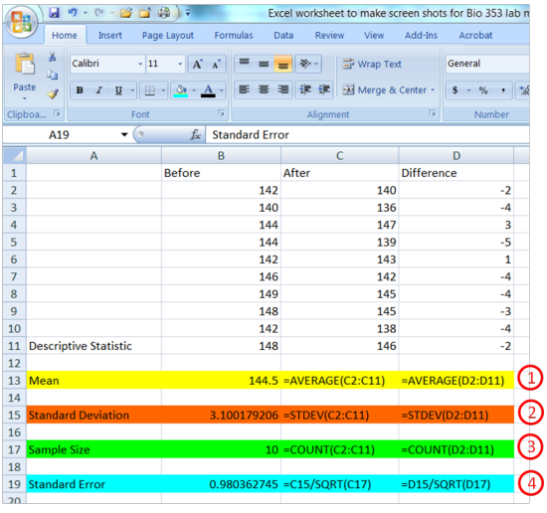

**FUNCTIONS**

1. **Count**

To count the number of cells that contain numbers, use the COUNT function.

***= COUNT(A1:A5)***

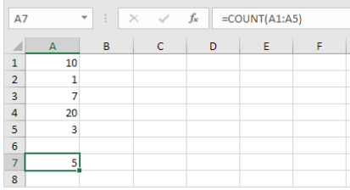

1. **Countif**To count cells based on one criteria (for example, greater than 9), use the following COUNTIF function.  
   ***= COUNTIF(A1:A5,”>9")***
2. **Countifs**To count cells based on multiple criteria (for example, green and greater than 9), use the following COUNTIFS function.  
   ***= COUNT(A1:A5,”green”,B1:B5,”>9”)***
3. **Sum**To sum a range of cells, use the SUM function.  
   ***= SUM(A1:A5)***
4. **Sumif**To sum cells based on one criteria (for example, greater than 9), use the following SUMIF function (two arguments).  
   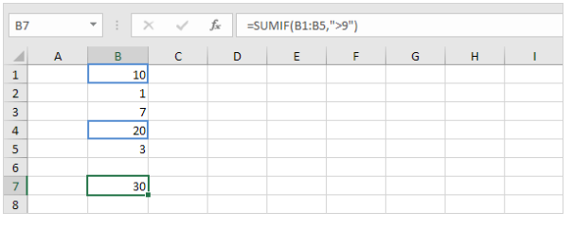  
   To sum cells based on one criteria (for example, green), use the following SUMIF function (three arguments, last argument is the range to sum).  
   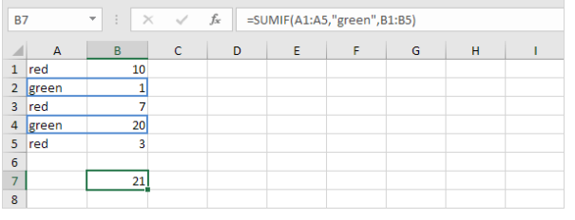
5. **Sumifs**To sum cells based on multiple criteria (for example, circle and red), use the following SUMIFS function (first argument is the range to sum).  
   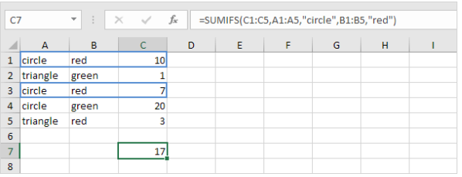

**LOGICAL FUNCTIONS**

1. **IF**The IF function checks whether a condition is met, and returns one value if true and another value if false.  
   1. For example, take a look at the IF function in cell C2 below.  
   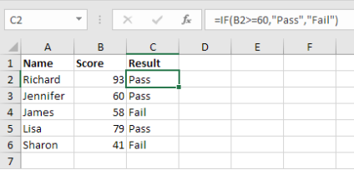
2. **AND**The AND Function returns TRUE if all conditions are true and returns FALSE if any of the conditions are false.  
   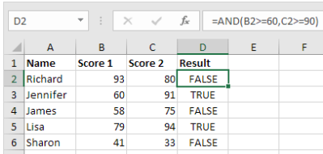
3. **OR**The OR function returns TRUE if any of the conditions are TRUE and returns FALSE if all conditions are false.  
   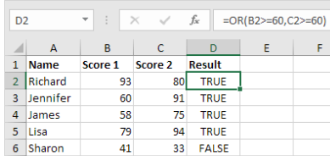
4. **NOT**The NOT function changes TRUE to FALSE, and FALSE to TRUE.  
   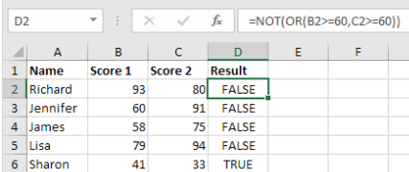

**Data Validation**

1. Select the range B2:B8.

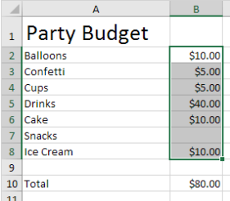  
Note: cell B10 contains a SUM function that calculates the sum of the range B2:B8.

2. On the Data tab, in the Data Tools group, click Data Validation.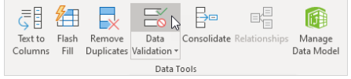

3. In the Allow list, click Custom.

4. In the Formula box, enter the formula shown below and click OK.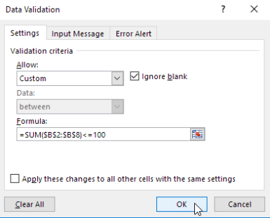

5. To check this, select cell B3 and click Data Validation.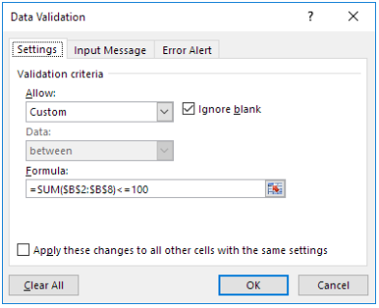

As you can see, this cell also contains the correct formula.

6. Enter the value 30 into cell B7. Result. Excel shows an error alert. You cannot exceed your budget limit of $100. Note: to enter an error alert message, go to the Error Alert tab.

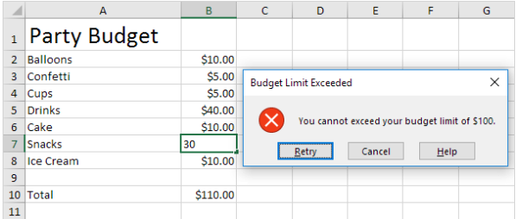

**TASKS :**

1. **Create a table containing 5 courses and reactive scores. Follow the given format.  
   (Note : Title can be created by merging the columns)  
   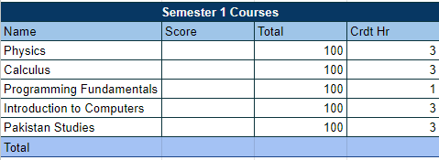**
2. **Create a duplicate of this table and use functions and formulas to calculate your total Score, Total score of course and total Crdt Hrs. Also calculate the summary statistics.**
3. **Add another column named Status and use Logical Function IF to generate an output of Pass or Fail  
   (Note : If Score > 60 Pass Else Fail)  
   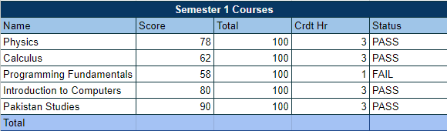**
4. **Perform Task 3 with AND Logical Function.  
   (True = PASS, FALSE = Fail)**
5. **Add Data Validation to the Total Score so that it can never exceed the limit of 100.**